ALL IN ONE
High Speed Dome
User’s Manual
(MODEL : VPD330WD-O, VPD370WD-O)

33x, 37x Crisp Image Detection

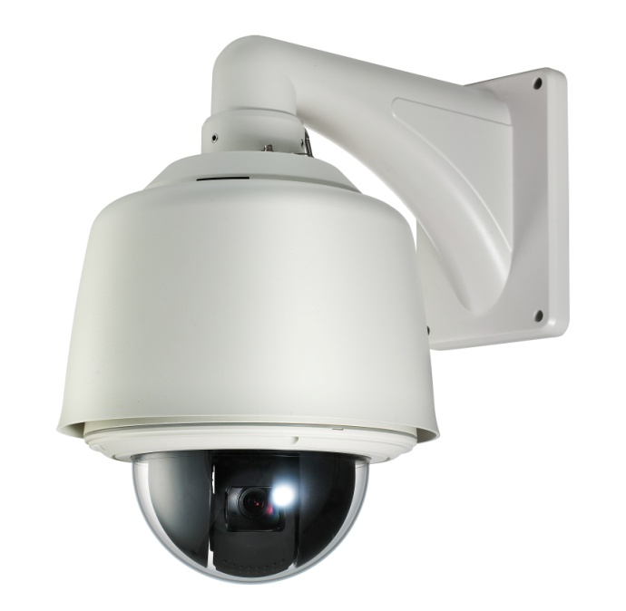



Please read this manual carefully before installation and operation of the product.

Contents

- Features ------------------------------------------------------------------------------- 3
2. Precaution --------------------------------------------------------------------------- 4
3. Part Names and Functions -------------------------------------------------- 5
◆ All-in-One Outdoor PTZ Camera
◆ Package Contents
◆ DIP Switch setting
◆ Camera ID setting
◆ RS-485 Communication setting
4. Installation ---------------------------------------------------------------------------- 13
5. Functional description ---------------------------------------------------------- 32
◆ Setup Menu Overview
◆ Main Menu
1) PAN/TILT setting
2) Camera setting
3) Autoseq setting
4) Zone setting
5) Alarm setting
6) Initialize setting
6. Product Structure ---------------------------------------------------------------- 32
7. Specifications ---------------------------------------------------------------------- 33

- Features
* Dynamic and precise AF control
The camera can trace and pick up the object, moving fast from the scene with powerful 324 times(Optical 27x, Digital 12x), 396 times(Optical 33x, Digital 12x), 444 times(Optical 37x, Digital 12x) zoom by greatly improved Auto Focus control.

* Removable Motorized IR Cut Filter(ICR)
* Viewable at total darkness
The image at daytime displays as True Color with IR Cut filter attached and turns to
Clear B/W(color signal removed) mode at night(True Day/Night). With ICR, it comes to IR sensitive and enables the camera to view the scene at total darkness.

*Super Wide Dynamic(sWDR)/ Only VPD330WD,VPD370WD
With new powerful DSP system integrated, it makes more 126 times upgraded Backlight
compensation than that of existing BLC system

* High resolution of 550TVL(Color)/ 680TVL(Night)

* Powerful 27x/ 33x/ 37x optical zoom

* Extremely upgraded sensitivity of 0.7Lux(Sens-up off)/ 0.002Lux(Sens-up, 256x)
/ 0.06Lux(B/W)
Clear difference with built –in Super DSP system and ICR mechanism is to surveil Objects clearly at even a starless dark night. In addition the built –in Dynamic Noise Reduction(DNR) removes noises and ghost effect to have the picture quality greatly improved.
It also saves the DVR’s recoding capacity up to 70%.

* Quick and Easy installation
Dome base is separated and easily mounted on the ceiling and the main body is simply hooked on it by hand with no tool. No complicated cable connection is additionally required with the built-in one-stop connection mechanism

- Precaution

Safety Precautions
* The purpose of this information is to ensure proper use of this product to prevent danger to damage to property. Please be sure to observe all precautions
* The precautions are divided into “Warnings” and “Cautions” as distinguished below;
Warning : Ignoring these warnings may result in death or serious injury.
Caution : Ignoring these cautions may result in injury or damage to property.

Warning :instructions alert you to  the potential risk of death  or serious injury | Caution : instructions alert you to the  potential risk of injury or  damage to property

Warnings
1. Be sure to use only the standard adapter which is specified in the specification sheet.
Using any other adapters could cause fire, electrical shock, or damage to the product.
2. When connecting the power supply and signal wires, check the external connection
terminal before connecting them. Connect the alarm signal wires to the alarm terminals,
the AC adaptor to the AC power input receptacle,
and the DC adapter to the DC power Input, making sure that the correct polarity is observed.
(Connecting the power supply incorrectly may cause fire, electrical shock,
or damage to the product.)
3. Do not connect multiple cameras to a single adapter.
(Exceeding the capacity may cause abnormal heat generation or fire.)
4. Securely plug the power cord into the power receptacle.
(Insecure connection may cause fire.)
5. When installing the camera on a wall or ceiling, fasten it securely and firmly.
(A falling camera may cause personal injury)
6. Do not place conductive objects(e.g. screwdrivers, coins, and metal things) or containers filled with water on top of the camera.
(Doing so may cause personal injury due to fire, electrical shock or falling objects)
7. Do not install the unit in humid, dirty, or sooty locations
(Doing so may cause fire or electrical shock.)

8. If any unusual smell or smoke comes from the unit, stop using the product.
In such case, immediately disconnect the power source and contact the store of purchase.
(Continued or modify this product in any way.)
9. When clean in use in such a condition may cause fire or electrical shock.)
10. If this product fails to operate normally, contact the store of purchase.
Never disassemble g, do not spray water directly onto parts of the product.
(Doing so may cause fire or electrical shock.)
Wipe the surface with a dry cloth. Never use detergents or chemical cleaners on the product, as this may result in discoloration of surface or cause damage to the finish.

Cautions
- Do not drop objects on the product or apply strong shock to it. Keep away from a location subject to excessive vibration or magnetic interference.
- Do not install in a location subject to high temperature(over 122℉), low temperature
(below 14℉) or high humidity. (Doing so may cause fire or electrical shock.)
- Avoid a location which is exposed to direct sunlight or near heat sources such as heater or radiators. (Neglecting to do so may result in a risk of fire.)
4. If you want to relocate the already installed product, be sure to turn off the power and then
move or reinstall it.
5. Install in a well-ventilated location.
6. Remove the power plug from the outlet when there is a lightning storm.
(Neglecting to do so may cause fire or damage to the product.)

3. Part Names and Function

◆ All-in-One Outdoor PTZ Camera

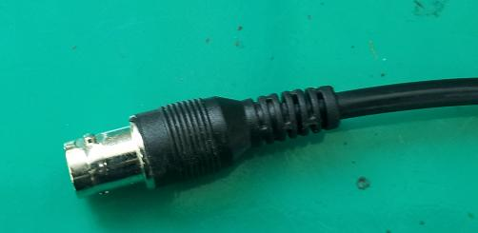

Video output

Power (24VAC)
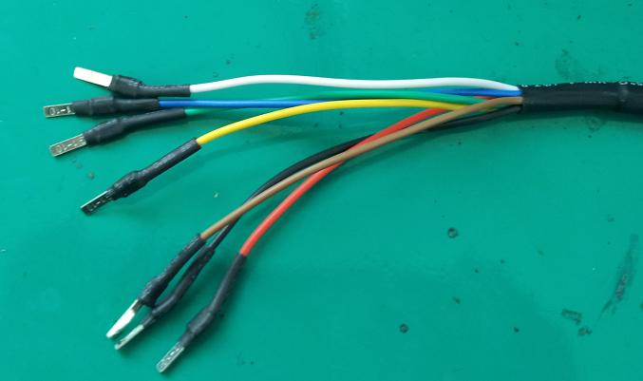

RS-485 DATA

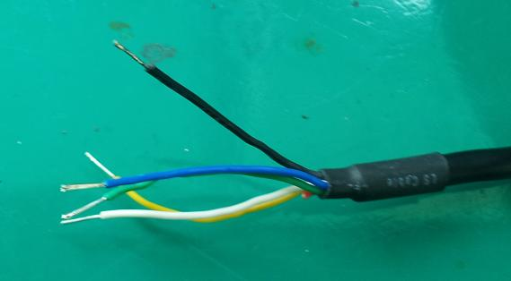

Relay output

Alarm Input

POWER Cable
COLOR | DESCRIPTION
YELLOW | EARTH
BROWN | RS485A
WHITE | RS485B
BLUE | AC24V+(Temperature Control Power)
Green | AC24V-(Temperature Control Power)
RED | AC24V+(Mechanism Power)
BLACK | AC24V-(Mechanism Power)

Alarm In/out Cable
COLOR | DESCRIPTION
BLACK | GND
YELLOW | ALARM INPUT 1
Green | ALARM INPUT 2
RED | ALARM INPUT 3
WHITE | ALARM OUT
BLUE | COM

◆ Package Contents
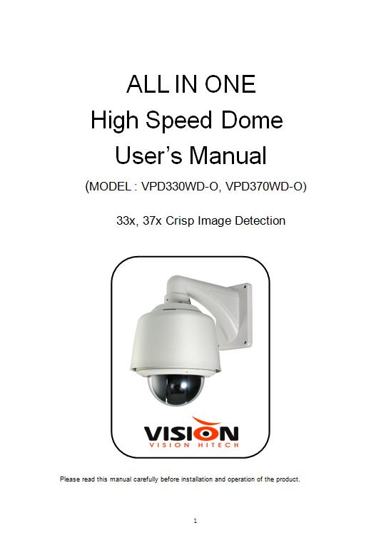

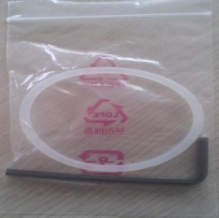
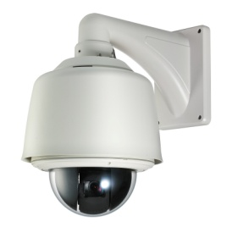

Instruction manual
1EA
Rubber Ring
1EA

Wide Dynamic 27x, 33x, 37x
Zoom Speed Dome Camera 1EA

[ Option ]
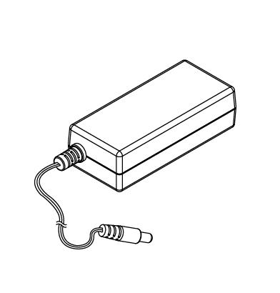
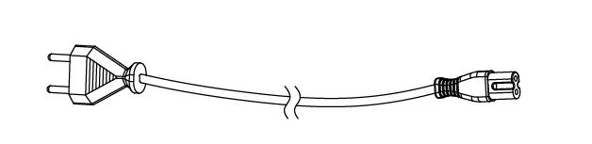
Adaptor(AC24V/2A)
1EA
Adaptor power plug
1EA
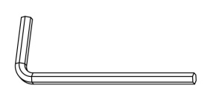
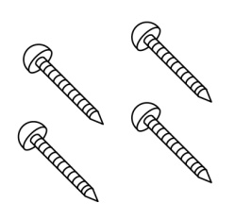
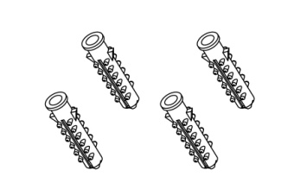
Tapping screw
4EA
Plastic anchor
4EA
Wrench
1EA
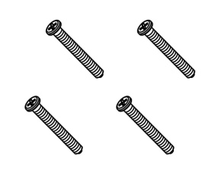
Fixed screw
4EA

z Note : Mount Brackets are optional
● Wall Mount Bracket | ● Ceiling Mount Bracket
 | 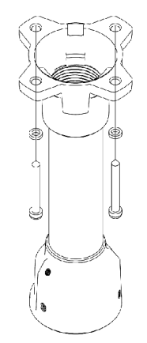
● Wall Mount with Junction Box | ● Corner and Pole Mount Bracket
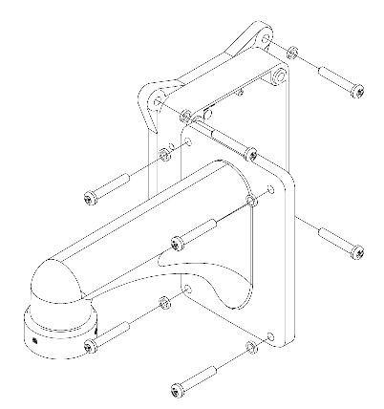

◆ DIP SWITCH SETTINGS
In a configuration where the camera’s RS485 data port is used for Camera control(pan, tilt, etc.) by the system controller, the camera’s DIP switches must be configured to specify the camera ID and communication parameters.
The camera mounting base needs to be removed to access the DIP switches.
See step 1 & 2 on page 11 for the information about how to remove the camera mounting base.

◆ Camera ID Setting
The factory default settings of these DIP switches are ID 1
(1-ON,0-OFF) SW1~SW8

DIP SW | ID | DIP SW | ID | DIP SW | ID
10000000 | 1 | 10101000 | 21 | 10010100 | 41
01000000 | 2 | 01101000 | 22 | 01010100 | 42
11000000 | 3 | 11101000 | 23 | 11010100 | 43
00100000 | 4 | 00011000 | 24 | 00110100 | 44
10100000 | 5 | 10011000 | 25 | 10110100 | 45
01100000 | 6 | 01011000 | 26 | 01110100 | 46
11100000 | 7 | 11011000 | 27 | 11110100 | 47
00010000 | 8 | 00111000 | 28 | 00001100 | 48
10010000 | 9 | 10111000 | 29 | 10001100 | 49
01010000 | 10 | 01111000 | 30 | 01001100 | 50
11010000 | 11 | 11111000 | 31 | 11001100 | 51
00110000 | 12 | 00000100 | 32 | 00101100 | 52
10110000 | 13 | 10000100 | 33 | 10101100 | 53
01110000 | 14 | 01000100 | 34 | 01101100 | 54
11110000 | 15 | 11000100 | 35 | 11101100 | 55
00001000 | 16 | 00100100 | 36 | 00011100 | 56
10001000 | 17 | 10100100 | 37 | 10011100 | 57
01001000 | 18 | 01100100 | 38 | 01011100 | 58
11001000 | 19 | 11100100 | 39 | 11011100 | 59
00101000 | 20 | 00010100 | 40 | 00111100 | 60
DIP SW | ID | DIP SW | ID | DIP SW | ID
10111100 | 61 | 11000110 | 99 | 10010001 | 137
01111100 | 62 | 00100110 | 100 | 01010001 | 138
11111100 | 63 | 10100110 | 101 | 11010001 | 139
00000010 | 64 | 01100110 | 102 | 00110001 | 140
10000010 | 65 | 11100110 | 103 | 10110001 | 141
01000010 | 66 | 00010110 | 104 | 01110001 | 142
11000010 | 67 | 10010110 | 105 | 11110001 | 143
00100010 | 68 | 01010110 | 106 | 00001001 | 144
10100010 | 69 | 11010110 | 107 | 10001001 | 145
01100010 | 70 | 00110110 | 108 | 01001001 | 146
11100010 | 71 | 10110110 | 109 | 11001001 | 147
00010010 | 72 | 01110110 | 110 | 00101001 | 148
10010010 | 73 | 11110110 | 111 | 10101001 | 149
01010010 | 74 | 00001110 | 112 | 01101001 | 150
11010010 | 75 | 10001110 | 113 | 11101001 | 151
00110010 | 76 | 01001110 | 114 | 00011001 | 152
10110010 | 77 | 11001110 | 115 | 10011001 | 153
01110010 | 78 | 00101110 | 116 | 01011001 | 154
11110010 | 79 | 10101110 | 117 | 11011001 | 155
00001010 | 80 | 01101110 | 118 | 00111001 | 156
10001010 | 81 | 11101110 | 119 | 10111001 | 157
01001010 | 82 | 00011110 | 120 | 01111001 | 158
11001010 | 83 | 10011110 | 121 | 11111001 | 159
00101010 | 84 | 01011110 | 122 | 00000101 | 160
10101010 | 85 | 11011110 | 123 | 10000101 | 161
01101010 | 86 | 00111110 | 124 | 01000101 | 162
11101010 | 87 | 10111110 | 125 | 11000101 | 163
00011010 | 88 | 01111110 | 126 | 00100101 | 164
10011010 | 89 | 11111110 | 127 | 10100101 | 165
01011010 | 90 | 00000001 | 128 | 01100101 | 166
11011010 | 91 | 10000001 | 129 | 11100101 | 167
00111010 | 92 | 01000001 | 130 | 00010101 | 168
10111010 | 93 | 11000001 | 131 | 10010101 | 169
01111010 | 94 | 00100001 | 132 | 01010101 | 170
11111010 | 95 | 10100001 | 133 | 11010101 | 171
00000110 | 96 | 01100001 | 134 | 00110101 | 172
10000110 | 97 | 11100001 | 135 | 10110101 | 173
01000110 | 98 | 00010001 | 136 | 01110101 | 174
DIP SW | ID | DIP SW | ID | DIP SW | ID
11110101 | 175 | 01010011 | 202 | 10100111 | 229
00001101 | 176 | 11010011 | 203 | 01100111 | 230
10001101 | 177 | 00110011 | 204 | 11100111 | 231
01001101 | 178 | 10110011 | 205 | 00010111 | 232
11001101 | 179 | 01110011 | 206 | 10010111 | 233
00101101 | 180 | 11110011 | 207 | 01010111 | 234
10101101 | 181 | 00001011 | 208 | 11010111 | 235
01101101 | 182 | 10001011 | 209 | 00110111 | 236
11101101 | 183 | 01001011 | 210 | 10110111 | 237
00011101 | 184 | 11001011 | 211 | 01110111 | 238
10011101 | 185 | 00101011 | 212 | 11110111 | 239
01011101 | 186 | 10101011 | 213 | 00001111 | 240
11011101 | 187 | 01101011 | 214 | 10001111 | 241
00111101 | 188 | 11101011 | 215 | 01001111 | 242
10111101 | 189 | 00011011 | 216 | 11001111 | 243
01111101 | 190 | 10011011 | 217 | 00101111 | 244
11111101 | 191 | 01011011 | 218 | 10101111 | 245
00000011 | 192 | 11011011 | 219 | 01101111 | 246
10000011 | 193 | 00111011 | 220 | 11101111 | 247
01000011 | 194 | 10111011 | 221 | 00011111 | 248
11000011 | 195 | 01111011 | 222 | 10011111 | 249
00100011 | 196 | 11111011 | 223 | 01011111 | 250
10100011 | 197 | 00000111 | 224 | 11011111 | 251
01100011 | 198 | 10000111 | 225 | 00111111 | 252
11100011 | 199 | 01000111 | 226 | 10111111 | 253
00010011 | 200 | 11000111 | 227 | 01111111 | 254
10010011 | 201 | 00100111 | 228 | 11111111 | 255

◆ RS485 Communication setting
Configuring DIP Switch as shown below resets communication parameters from the factory default setting by using SW9 and SW10
SW10 | SW9 | BUAD RATE | PROTOCAL
0 | 0 | 9600BPS | PELCO-D
0 | 1 | 4800BPS | PELCO-D
1 | 0 | 9600BPS | PELCO-P
1 | 1 | 4800BPS | PELCO-P
- Factory Default : 9600bps, PELCO-D

4. Installation

■ PTZ Camera with Bracket
Installation using Wall Mount Bracket
① Make a hole whose diameter is 30~40mm on the mounting surface to pass the wire(s) and cable(s) through the mounting surface. (In case of the wiring and cabling through the mounting surface only) Then prepare the wall mount bracket. Pull the wire(s) and cable(s) for the system as below. Attach the wall mount bracket to the mounting surface.
(Tapping Screw 6×50)
② When the reservation line for the wall outside connection, have to puncture
The bracket line hole first, then reserve line traversing the line hole and
The bracket hole, then fix with 4 hexagonal screws in the install position
When the cables are on the wall surface, puncture this area for cable outlet
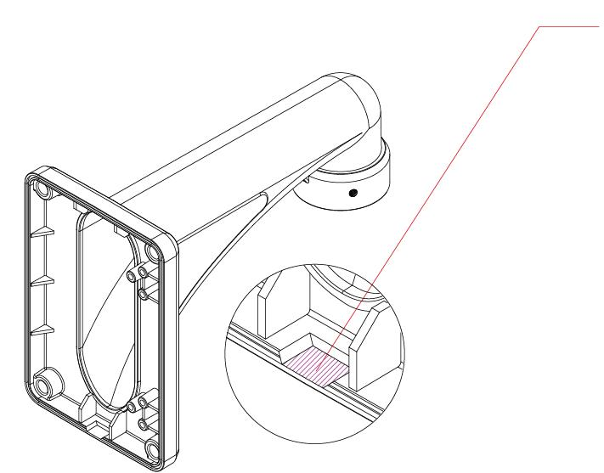

③ High speed dome safety rope lock catch with the bracket reservation hole,
Then keeps the high speed dome a line and the corresponding electric cable
Group a line connection, picks up the high speed dome, screw tight three
Clamping screws

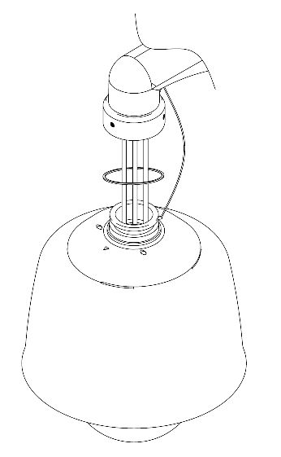
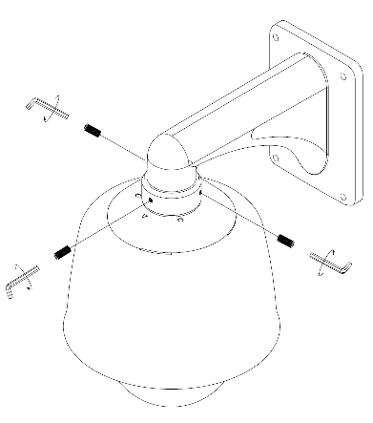

- Screw the dome cover to the main body and remove the protection vinyl from the dome cover.
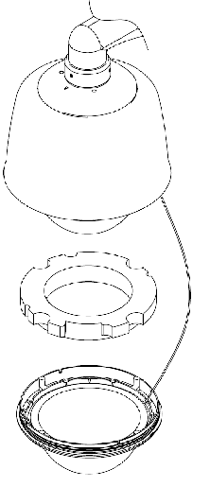

Notice
Before starting the installation, make sure that the Camera ID and Protocol are set up properly

Installation using Wall Mount Junction Box Bracket
① Install the 4 install holes to aim at 4 expansion of metal bolt, twist the upper nut Fixedly,
loosen the water joint, reserve the electric cable group to going beyond a Line traversing
water joint then screw tight again, installation finished.

② High speed dome safety rope lock catch with the bracket reservation hole, Then keeps
the high speed dome a line and the corresponding electric cable Group a line connection,
picks up the high speed dome, screw tight three Clamping screws

③ Screw the dome cover to the main body and remove the protection vinyl from
the dome cover.

Notice
Before starting the installation, make sure that the Camera ID and Protocol are set up properly

Installation using Ceiling Mount Bracket
① When wires go though wall, cable assembly backup wires directly cross bracket hole.
Four installation holes aligns four inflation bolt and then twist nut to fasten
(Tapping Screw 6×50)
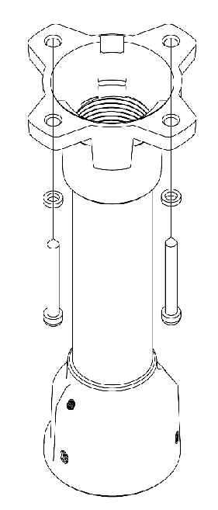
② When wires pass outside wall, firstly drill the terminal hole, and then cables
Assembly backup wires cross it and the bracket hole by turns.
Finally four installation holes aligns four installation holes aligns four inflation bolt and then
twist nut to fasten

When the cables are on the ceiling surface, first puncture this area.
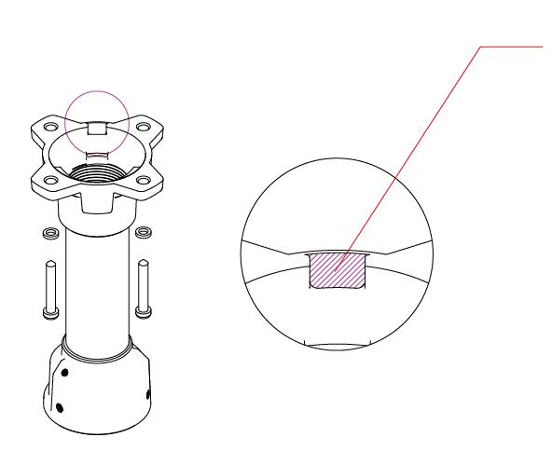

③ High speed dome safety rope lock catch with the bracket reservation hole,
Then keeps the high speed dome a line and the corresponding electric cable Group a line
connection, picks up the high speed dome, screw tight three Clamping screws

- Screw the dome cover to the main body and remove the protection vinyl from the dome cover.

Notice
Before starting the installation, make sure that the Camera ID and Protocol are set up properly

OPTIONAL ACCESSORIES FOR INSTALLATION
- If installing the wall mount on an at least 80mm-long cylinder
● Pole Mount
② If installing the wall mount on a corner of the wall
● Corner Mount

5. Functional Description
◆ Setup Menu Overview
In this chapter, we will look over the overall structure of the Setup Menu and then look at the functions of each menu
PAN/TILT ID DISPLAY → ON/OFF
SET CAMERA NAME → OFF/(ON)
FIRMWARE → XXX
MANUAL SPEED → 10~110°/Sec
PROPO. P/T → ON/OFF
DIGITAL FLIP → ON/OFF
IMAGE HOLD → OFF/ON
AUTORUN TIME → OFF/20~60Sec
EXIT
CAMERA
SET BACKLIGHT <WDR>
OFF/<WDR>/<USER> <HLC>
WDR WDR LIMIT → LOW/MID/HIGH
WDR LEVEL → 0~100
BLC LEVEL → LOW/HIGH
WINDOW TOP → 1~100
WINDOW BOTTOM → 1~100
WINDOW LEFT → 1~100
WINDOW RIGHT → 1~100
HLC HLC LEVEL → LOW/HIGH
MASK COLOR → 0~10
MD MD NUM → 1~8
MD DEFINE → OFF/ON
MD DISPLAY → OFF/ON
SENSITIVITY → LOW/HIGH
AREA TOP → 1~26
AREA BOTTOM → 5~39
AREA LEFT → 1~44
AREA RIGHT → 5~48
EXIT
ATW ATW MODE→ ATW/MANUAL
/<HOLD>/IN DOOR
/OUT DOOR

MANUAL RED → 0~200
MANUAL BLUE → 0~200
EXIT
FOCUS FOCUS MODE→
/ZOOM MANUAL/AUTO/ZOOMTG
ZOOM TRK MODE→OFF/ON
ZOOM TRK SPD→FAST/SLOW
DIGITAL ZOOM→OFF/ON
ZOOM MAG→
2X/4X/6X/8X/10X/12X
ZOOM SPEED → 1~8
EXIT
AE BRIGHTNESS → 0~100
IRIS → AUTO/MANUAL
IRIS MANUAL → F1.6 ~CLOSE
SHUTTER → ESC/MAN/A.FLK
SHUTTER MANUAL→X256~1/120000
AGC → OFF/LOW/MID/HIGH
SSNR → OFF/LOW/MID/HIGH
DSS → X2~X256, OFF
EXIT
DAY D/N MODE → COLOR/BW/AUTO
& NIGHT BUST MODE → OFF/ON
BURST LEVEL → 0~100
DURATION → FAST/SLOW
FILTER DELAY → 5/7/10/20/30/
40/60SEC
EXIT

SPECIAL H-REV → OFF/ON
V-REV → OFF/ON
Stabilizer → OFF/ON
SHARPNESS → 0~100
COLOR → 0~100
EXIT

AUTOSEQ PRESET PRESET NO → 1~128
SET PRESET
DEFINE → OFF/<ON>
PRESET
NAME → OFF/<ON>
P/T
POSITION→P/T ANGLE
BRIGHTNESS → 0~100
ATW → <SET>
BLC → <SET>
EXIT
TOUR TOUR NO → 1~5
TOUR NO DEF
→ OFF/<ON>
NAME → TOURGROUP1
TOUR NAME
DEF→OFF/<ON>
DWELL TIME → 1~120
EXIT
SCAN SCAN NO →1~5
SCAN DEFINE → OFF/ON
NAME → SCANGROUP1
SCAN NAME
DEFINE→OFF/<ON>
PAN START POS→<180>
PAN END POS→<350>
TILT POS →<45>
SCAN SPEED
→2˚,5˚,10˚,20˚/S
EXIT
PATTERN PATT NUMBER -> 1~2
PATT DEFINE
→ OFF/ON
NAME → PATTERN001
PATT NAME
DEF→OFF/<ON>
PATT RECORD
→OFF/<ON>
PATT SPEED
→2˚,5˚,10˚,20˚/S
EXIT

AUTO PAN TILT ANGLE → (xxx)
PAN SPEED
→2˚,5˚,10˚,20˚/S
DIRECTION
→ CW/CCW
EXIT
AUTO MODE →
OFF/SEQ/TOUR/SCAN/PATT/A.PAN
HOME POSITION → OFF/1~128
EXIT

ZONE AREA SEL → 1~8
SET AREA DEFINE → OFF/ON
AREA NEW SET → OFF/ON
TOP/BOTTOM-1 → XXX
TOP/BOTTOM-2 → XXX
LEFT/RIGHT-1 → XXX
LEFT/RIGHT-2 → XXX
EXIT

ALARM ALARM DISPLAY → OFF/ON
SET ALARM IN → <SET>
ALARM OUT → OFF/ON
TIME OUT → 1~10SEC
EXIT

INITIALIZE POWER ON RESET
SET PAN/TILT INIT
CAMERA INIT
AUTOSEQ INIT
PRIVACY ZONE INIT
FACTORY INIT
EXIT

◆ Main Menu
SYSTEM INFO
This diagram shown above illustrates the
overall structure of the setup menu.
In this section, a description of the setup menu
features will enable users to tailor it to their
personal needs

MAIN MENU

1. PAN TILT SET
2. CAMERA SET
3. AUTOSEQ SET
4. ZONE SET
5. ALARM SET
6. INITIALIZE SET
7. EXIT
Selection : UP,DOWN KEY
Menu open : IRIS OPEN Or 95+GOPRESET
Menu close : IRIS CLOSE KEY
1. PAN TILT SET

1.ID DISPLAY: | <ON>/OFF
2. CAM NAME: | OFF/<ON>
3. FIRMWARE: | XXX
4. MANUAL SPEED | 10~110°/SEC
5. PROPO. P/T: | ON/OFF
6. DIGITAL FLIP: | ON/ OFF
7. IMAGE HOLD | OFF/ON
8.AUTORUN TIME: | OFF/20~60SEC
9.EXIT

Selection : UP, DOWN, LEFT, RIGHT KEY
Menu open : IRIS OPEN KEY
Menu close : IRIS CLOSE KEY

■ ID DISPLAY – Camera ID appears on the screen.
OFF : The ID does not appear on the screen.
<ON> : The ID appears on the screen.
When changing the location of the ID, press
IRIS OPEN KEY in the condition of <ON>.
Then, you can move to ID DISPLAY Menu.
■ CAM NAME – Maximum of 10 characters can be
input. When changing the camera
name, press the IRIS OPEN Key
after NAME DISPLAY is set to <ON>.
■ MANUAL SPEED
Adjustable maximum speed when PAN/ TILT
are manually controlled.
■ PROPO. P/T
Automatically adjusts the PAN/TILT movement speed according to the Zoom magnification level.
OFF: PAN/TILT movement is not automatically controlled.
ON : The PAN/ TILT speed slows down on higher
zoom magnification.
■ DIGITAL FLIP
OFF : It operates TILT below 90°.
ON : It operates TILT over 90°.
■ FREEZE
When you move to Preset, the screen displays
the frozen image of the current displayed preset.
OFF : It displays the current image.
ON : It displays the frozen image.
<Caution>
FREEZE works at TOUR in AUTORUN MODE.
■ AUTORUN TIME
If a PAN/TILT operation overruns its setting value AUTO REFRESH automatically compensates.

1.1. ID DISPLAY
ID location can be changed as follows.
1. Select <ON> from ID DISPLAY.
2. Press IRIS OPEN KEY.
MOVE: U/D/L/R
EXIT: IRISCLOSE
Selection : UP, DOWN, LEFT, RIGHT KEY
Menu open : IRIS OPEN KEY
Menu close : IRIS CLOSE KEY

1.2 CAMERA NAME DISPLAY

CAMERA NAME: MAINCAMERA
0123456789ABCDEFGH
IJKLMNOPQRSTUVWXYZ
DELETE : <IRISOPEN>
POSITION : <IRISOPEN>
EXIT

Selection : UP, DOWN, LEFT, RIGHT KEY
Menu open : IRIS OPEN KEY
Menu close : IRIS CLOSE KEY

The method of Camera naming is as follows;
- Select DELETE and cancel MAINCAMERA
by pressing the IRIS OPEN KEY.
- Move to the desired characters from 0 to
Z and press the IRIS OPEN KEY.
3. Repeat step 2 until the name is completed.
4. If you want to change the location of the
camera name, select position and press
the IRIS OPEN KEY.
How to change the location of camera
name is the same as changing ID DISPLAY

2. CAMERA SET

1.BACKLIGHT-----OFF/WDR/USER/HLC
2. MOTION DET --------<SET>
3. ATW --------------<SET>
4. FOCUS/ZOOM ---------<SET>
5. AE ------------------<SET>
6. DAY&NIGHT ----------<SET>
7. SPECIAL -------------<SET>
8. EXIT
2.1. BACK LIGHT
WDR(for Optical 33x/ 37x zoom only), USER
AREA & HLC are selectable.

* WDR *
It is an ideal set up for the most of different
levels of backlit or contrast lighting situations
and provides no darker subjects when there
are a dark portion and a bright portion on the
screen simultaneously.

* HLC *
It cuts off the strong light like “headlight” to
recognize a license plate or subject clear in
the entrance of parking garage or at gas station.
It doesn’t work at daytime.

* USER AREA*
User can set area to recognize the specific area
clear.
.

2.1.1. WDR LEVEL SETUP

1. WDR LIMIT: | LOW/MID/HIGH
2. WDR LEVEL: | 0~100
3. EXIT
■ WDR LIMIT
Sensitivity of WDR can be controllable to
LOW/MIG/HIGH. If the sensitivity gets higher,
the contract between dark areas and bright
areas becomes lessened.
■ WDR LEVEL
Brightness of WDR image can be wholly
adjustable.
<Caution>
1. If SHUTTER is set to MANUAL,
WDR function doesn’t work.
2. In case that color of image goes wrong
according to the lighting condition and
noise occurs in the bright area under
WDR selection, do not use WDR function.

2.1.2. BLC USER SETUP

1. WINDOW | OFF/ON
2. LEVEL | LOW/HIGH
3. WINDOW TOP | 1~100
4. WINDOW BOTTOM | 1~100
5. WINDOW LEFT | 1~100
6. WINDOW RIGHT | 1~100
7. EXIT
Above menu is selectable and adjustable by
controller.

2.1.3. HLC LEVEL SETUP

1. HLC LEVEL | LOW/HIGH
2. MASK COLOR | 0~10
3. EXIT
■ HLC LEVEL
Sensitivity is adjustable.
■ MASK COLOR
Masking color on the high light is adjustable.

2.2. MOTION DETECT

1. MD NUM : | 1~8
2. MD DEFINE : | OFF/ON
3. MD DISPLAY : | OFF/ON
4. AREA DISPLAY | OFF/ON
5. SENSITIVITY | LOW/HIGHT
6. AREA TOP | 1~26
7. ARA BOTTOM | 5~30
8. ARA LEFT | 1~44
9. AREA RIGHT | 5~48
10.EXIT

If MD DISPLAY is set to ON, “MOTION” appears
on the bottom right.
Motion Detection doesn’t work when
OSD MENU is activated.

■ MD DEFINE
When DEFINE is ON, MD AREA can be set up
to 8.
■ SENSITIVITY
Sensitivity of Motion Detection is adjustable.
If the sensitivity gets higher, there is a possibility
to have incorrect workings.
<Caution>
- Motion Detection doesn’t work in
SCAN & PATTERN setting.
- When user uses MD, DWELL TIME should
be set over 3 seconds at least in TOUR setting.
- If there is a shaken lighting directly, do not
set the MD because there may be an
incorrect working.
- If there is an instant change for lights which
has an effect on the subject, an incorrect
working may occurs.
- This MD function is for neither fire protection
nor antitheft so that provider is free from
any responsibilities of the malfunction.

2.3. ATW

1. ATW MODE: | AUTO/MANUAL/<HOLD>/OUT DR/IN DR
2. MANUAL RED: | 0 ~ 200
3. MANUAL BLUE: | 0 ~ 200
4. EXIT
Menu Shift : UP, DOWN, LEFT, RIGHT KEY
Menu Open : IRIS OPEN KEY
Menu Close : IRIS CLOSE KEY
It is set to White Balance under any lighting
conditions.
■ ATW MODE ➔ ATW
White Balance is compensated automatically.
■ ATW MODE ➔ < HOLD >
White Balance will be optimized under the
current light condition. If the light condition is
changed, White Balance should be readjusted.
It works by pressing IRIS OPEN KEY when
< HOLD > is off.
■ ATW MODE ➔ OUT DR
White Balance will be optimized under the
outdoor environment.
■ ATW MODE ➔ IN DR
White Balance will be optimized under the
indoor environment.
■ ATW MODE ➔ MANUAL
White Balance is adjustable by RED and BLUE
gains manually.

<Caution>
1. When it is too dark or bright on the background,
White Balance may not function properly.
2. At the place the camera is directed towards
the fluorescent light or lighting conditions are
changeable, White Balance may work improperly.

2.4. FOCUS/ZOOM

1. FOUCS MODE: | MANUAL/AUTO/ZMTRG
2. ZOOM TRK MODE: | ON/OFF
3. ZOOM TRK ZPEED: | FAST/SLOW
4. DIGITAL ZOOM: | OFF/ON
5. ZOOM MAG: | 2X/4X/6X/8X/10X/12X
6. ZOOM SPEED | 1~8
7. EXIT
■ FOCUS MODE
* MANUAL
FOCUS is adjustable manually.
* AUTO
FOCUS is adjustable automatically.
* ZMTRG
Whenever ZOOM is changed, FOCUS is also
readjusted.
■ ZOOM TRK MODE
When ZOOM is changed in Wide <-> Tele,
user can select if FOCUS will be worked or not.
It is applied only to AUTO and ZOOM TRK mode.
When user moves ZOOM to a specific area and
wants to get faster, ZOOM TRK MODE should
be set to Off.
<Caution>
Under the following conditions, AUTO FOCUS may
not work properly.
1. When the lux level is too low or too high
2 .When a short distance object and a close
distance object appear together in a monitoring area.
3. When there is no contrast between Black and White.
2.5. AE

1. BRIGHTNESS: | 0 ~ 100
2. IRIS: | AUTO/MANUAL
3. IRIS MANUAL: | F1.6 ~ CLOSE
4. SHUTTER: | ESC/MANUAL/A.FLK
5. SHUTTER MANUAL: | X256~1/120000
6.AGC: | OFF/LOW/MID/HIGH
7. SSNR: | OFF/LOW/MID/HIGH
8. DSS: | X2~X256, OFF
9. EXIT
■ BRIGHTNESS
Brightness on the screen is adjustable.
■ IRIS
The brightness on the screen can be
adjustable depending on the amount of light
through exposure meter.
AUTO : The exposure meter is adjusted automatically.
MANUAL : User can adjust the exposure meter
manually to optimize the brightness
on the screen.
■ SHUTTER
When capturing a subject, moving fast or under low
light condition, user can adjust the shutter speed
to faster or slower to get improved images.
ESC : Shutter speed is controlled automatically
according to the brightness on the screen.
MANUAL : Shutter speed is controlled in
1/20000 ~ X128 manually.
- FLK : Use this mode when the screen flickers
due to the inconsistent frequency under
surrounding lights.
In this mode, shutter speed fixed at 1/100 sec.
In NTSC system and 1/120 sec. in PAL system.
■ SHUTTER MANUAL
Shutter speed is controllable only when SHUTTER
is set to MANUAL.

■ AGC
Auto Gain Control is to brighten the screen under
the low light condition.
■ SSNR ( DIGITAL NOISE REDUCTION )
Noise is lessened under the low light condition.
OFF : Noise reduction has no effect.
LOW: Noise reduction effect is small but there is
little afterimage.
MID: Noise reduction effect generally goes proper
and afterimage is not strong.
HIGH: Noise reduction effect is excellent but
afterimage is also strong.
■ DSS
By controlling Electronic Shutter, it makes the
screen brightened under the low light condition.
However, if user sets higher ratio of DSS, afterimage
becomes stronger and Auto Focus may not work.
<Caution>
1. If possible, do not use A.FLK and WDR mode at
the same time.
2. In internal synchronization system, if SHUTTER is
set to ESC and the camera faces to sunlight or
strong light reflecting areas directly, the screen
goes wrong. In this case, change the location of
the camera.
3. In case that SHUTTER is set to MANUAL or A.FLK,
SENSUP LIMIT doesn’t work.
4. SSNR doesn’t work when AGC is OFF.

2.6. DAY&NIGHT

1. D/N MODE: | COLOR/BW/AUTO
2. BURST MODE: | OFF/ON
3. BURST LEVEL: | 0 ~ 100
4.DURATION: | FAST/SLOW
5. FILTER DELAY: | 5/7/10/15/20/30/40/60SEC
6. EXIT
B/W mode with removed IR cut filter offers
crystallized clear image under low light condition.
On the contrary, Color mode with replaced
IR cut filter works at daytime.
■ D/N MODE
AUTO : Color mode at daytime and B/W mode
at nighttime. It is switchable automatically
according to the designated lux condition.
■ BURST MODE
OFF : BURST signal is removed.
ON : BURST signal is output with together B/W
Luminance signal.
■ BURST LEVEL
BURST LEVEL is adjustable when D/N MODE is
COLOR.
■ DURATION
Switching over lux condition is selectable in
DAY<->NIGHT
 | DAY->NIGHT | NIGHT->DAY
FAST | 2.5LUX | 4LUX
SLOW | 0.8LUX | 6LUX

■ FILTER DELAY
The duration of Dwell Time of both the lighting
conditions can be customized to let the camera
divert between daytime and nighttime settings.

<Caution>
- When AGC is OFF, AUTO MODE doesn’t
work while COLOR or B/W mode works.
- If sunlight or halogen lamp is used in
B/W mode, Focus may be blurred or dimmed.
2.7. SPECIAL

1. H-REV: | OFF/ON
2. V-REV: | OFF/ON
3. DIS: | OFF/ON
4. SHARPNESS: | 0~100
5. COLOR: | 0~100
6. EXIT
■ H-REV
The screen flips horizontally.
■ V-REV
The screen flips vertically.
■ DIS
Digital Image Stabilizer compensates the screen
from an unstable environment which can move
the camera.
■ SHARPNESS
Overall sharpness on the screen is adjustable.
■ COLOR
Overall color density on the screen is adjustable.

3. AUTOSEQ SET

1. PRESET | <SET>
2. TOUR | <SET>
3. SCAN | <SET>
4. PATTERN  5. AUTO PAN | <SET>  <SET>
6. AUTO MODE SET  7. HOME POSITION  8. EXIT | OFF/SEQ/TOUR/SCAN/  PAN/A.PAN  OFF/1~128
Menu Shift : UP, DOWN, LEFT, RIGHT KEY
Menu Open : IRIS OPEN KEY
Menu Close : IRIS CLOSE KEY
PRESET : Location of the current PAN/TILT and
ZOOM can be programmed. In ALARM
or TOUR operation, the camera moves
to the programmed preset.
SEQ : The programmed PRESET is executed
from the lower order successively.
TOUR : PRESET works in GROUP. Up to 5
presets per group can be registered and up
to 5 groups can be operated.
SCAN : PAN movers from the starting point
and the ending point and up to 5 scans
can be set up.
PATTERN : The operation path of PAN/TILT is saved
and PATTERN plays PAN/TITL according
to the operation path.

■ AUTO MODE SET
OFF : It keeps on Operation Standby condition.
TOUR, SCAN, PATT : They will be executed
automatically after user exits OSD MENU.
■ HOMEPOSITION
If there is any loss of power the camera goes to the
programmed Preset.

<Caution>
If AUTORUN is set the camera does not go to the
programmed Preset.

3.1. PRESET
This function is to move the designated position
if user selects the desirable target and location.
1. PRESET NO: | 1~128
2. PRESET DEFINE: | OFF/<ON>
3. PRESET NAME: | OFF/<ON>
4. P/T POSITION: | P/T ANGLE
5. BRIGHTNESS: | 0~100
6. ATW: | <SET>
7. BLC: | OFF/<WDR>/<USER>/<HLC>
8. EXIT
Menu Shift : UP, DOWN, LEFT, RIGHT KEY
Menu Open : IRIS OPEN KEY
Menu Close : IRIS CLOSE KEY
■ PRESET NO
Total 128 presets can be set up.
Change of PRESET NO is done by
LEFT and RIGHT KEY.
■ PRESET DEFINE
OFF : PRESET doesn’t work
ON : Applicable PRESET is workable.
Location change of PAN/TILT/ZOOM in
PRESET is as follows.
- After PRESET DEFINE is changed from
OFF to ON, press IRIS OPEN KEY
- Locate PAN/TILT to the desirable place.
PREST NAME: PRESET0001
PAN: XXX
TILT: XXX
ZOOM: T/W EXIT: IRIS CLOSE
- If user wants to the location of ZOOM, press
TELE or WIDE button of controller.
- Finalize FAN/TILT and ZOOM settings by
pressing IRIS CLOSE KEY.
■ PRESET NAME
OFF : After PRESET works, PRESET name is not
displayed on the screen.
<ON> : After PRESET works, PRESET name is
displayed on the screen.
Default of PRESET name is PRESET0001 and the
method of editing is as follows.
- After changing PRESET NAME from OFF to
<ON> and press IRIS OPEN KEY.
- How to edit PRESET NAME is the same
as “1.2 CAMERA NAME DISPLAY”.
■ BRIGHTNESS
The brightness of the current PRESET is adjustable.
■ ATW
The White Balance of current PRESET is
selectable. The setting is as follows.
1. Select ATW menu
2. Press IRIS OPEN KEY in <SET>.
3. How to set up ATW is the same as “2.3. ATW”.
■ BLC
When the subject gets darker under the bright
background in the current PRESET, this function
is useful.
How to set up is as follows.
1. Select BLC menu.
2. Press IRIS OPEN KEY in <SET>.
3. How to set up ATW is the same as “2.1. BLC”
<Caution>
- When setting PRESET by the shortcut key,
PRESET can be set in No.1-No.64 and,
regarding over No.65, it should be set up
by OSD Menu.
- Default set up value of BRIGHT, BLC and
ATW in PRESET is decided by Factory Default.

3.2. TOUR
This function is to repeatedly operate
Group Surveillance with programmed presets
1. TOUR NO: | 1 ~ 5
2. TOUR NO DEF: | OFF/<ON>
3. NAME: | TOURGROUP1
4. TOUR NAME DEF: | OFF/<ON>
5. DWELL TIME: | 1~120
6. EXIT
■ TOUR NO
Maximum 5 groups can be registered.
■ TOUR NO DEF
OFF : TOUR Group setting is cancelled.
ON : TOUR Group is set up.
<Setting example>
TOUR NO | 1 | 2 | 3 | 4 | 5
TOUR DEF | ON | OFF | ON | OFF | ON
TOUR will be executed in programmed preset 1, 3 & 5.
How to set TOUR GROUP 1 in PRESET is as follows.
1. Register “1” as a TOUR NO.
2. After changing TOUR NO DEF from OFF
to <ON>, press IRIS OPEN KEY.
1. PRESET NUMBER | OFF/1~128
2. PRESET NUMBER | OFF/1~128
3. PRESET NUMBER | OFF/1~128
4. PRESET NUMBER | OFF/1~128
5. PRESET NUMBER | OFF/1~128
3. Input desirable PRESET No. from 1 in serial order.
4. Press IRIS CLOSE KEY to finalize the setting.
■ NAME
It changes the name of TOUR GOURP,.
How to change the name is as follows.
- After TOUR NAME DEF changes from OFF to
<ON>, press IRIS OPEN KEY.
- How to change the Tour group name is the same
as “1.2 CAMERA NAME DISPLAY”.

■ DWELL TIME
It is a waiting time between PRESET execution and
next PRESET.

<Caution>
1. If TOUR GOURP1 PRESET is set up as follows.
1. PRESET NUMBER | 1
2. PRESET NUMBER | 2
3. PRESET NUMBER | 3
4. PRESET NUMBER | OFF
5. PRESET NUMBER | 4
After operating as
PRESET1 -> PRESET2 -> PRESET3, it is returned
to PRESET1.
Namely, if there is “OFF” during the operation in
serial order, it is returned to the first preset

3.3. SCAN
This function is to surveil the designated two
points in the designated speed by automatic
travel back and forth.
1. SCAN NO | 1 ~ 5
2. SCAN DEFINE | OFF/ON
3. NAME | SCANGROUP1
4. SCAN NAME DEF | OFF/<ON>
5. PAN START POS | <180>
6. PAN END POS | <350>
7. TILT POS | <45>
8.SCAN SPEED | 5°,10°,15°,20°/S
9. EXIT

■ SCAN NO
Maximum 5 Scans can be registered.
■ SCAN NO DEF
OFF : SCAN is cancelled
ON : SCAN can be set up (it should be
“ON” for the operation in AUTO RUN)

<Setting example>
SCAN NO | 1 | 2 | 3 | 4 | 5
SCAN DEF | ON | OFF | ON | OFF | ON
SCAN will be executed in programmed preset 1,3 &5.
How to set up SCAN1 in PRESET is as follows.
1. Register “1” as s SCAN NO.
2. After changing SCAN DEFINE from OFF to
<ON>, press IRIS OPEN KEY.
■ NAME
It changes SCAN Name.
How to change is as follows.
- After changing SCAN NAME DEF from OFF to
<ON>, press IRIS OPEN KEY.
- How to change the SCAN name is the same as
“1.2 CAMERA NAME DISPLAY”.
■PAN START POS
It sets up the initialized location of SCAN.
Controllable angle is 0~ 360° , 0 ~ -360°.
How to set up is as follows.
1. Press IRIS OPEN KEY in PAN START POS.
PAN START POSITION SET
PAN START POSITION: XXX
EXIT: IRIS CLOSE
PAN Shift : LEFT, RIGHT KEY
2. After shifting to a desirable position, press
IRIS OPEN KEY.
■ PAN END POS
It sets up the terminated location of SCAN.
Controllable angle is 0°~ 360°, 0°~-360°.

How to set up PAN END POS is the same as
“PAN START POS”.

■ TILT POS
It sets up TILT angel in SCAN.
Controllable angle is 0~ 90° .
How to set up is the same as “PAN START POS”
but UP, DOWN KEY should be used for TILT
operation.
■ SCAN SPEED
It sets up SCAN Speed..The speed can be set up
in 5°/S(Slow) ~ 20°/S(Fast).
<Caution>
The value of Brightness, WDR, ATW is applied
to the setting values on the OSD.

3.4. PATTERN
It is to memorize the paths operated with the
joystick operation and reenact them..
1. PATT NUMBER | 1 ~ 2
2. PATT DEFINE | OFF/ON
3.NAME | PATTERN001
4.PATT NAME DEF | OFF/<ON>
5.PATT RECORD | OFF/<ON>
6.PATT SPEED | 5°,10°,15°,20°/S
7. EXIT
MENU Shift : UP, DOWN, LEFT, RIGHT KEY
MENU Open : IRIS OPEN KEY
MENU Close : IRIS CLOSE KEY
■ PATT DEFINE
OFF : PATTERN is cancelled
ON : PATTERN is set up.
If operating it in AUTO RUN, PATT DEFINE should
to be ON.
■ NAME
It changes PATTERN Name..
How to set up is as follows..
1. After changing PATTERN NAME DEF from
OFF to <ON>, press IRIS OPEN KEY.
2. How to change the name is the same as
“1.2 CAMERA NAME DISPLAY”.
■ PATT RECORD
OFF : PATTERN is not memorized.
ON : PATTERN is memorized.
How to set up PATTERN
1. After PATT RECORD changes from OFF to
<ON>, press IRIS OPEN KEY.
MEMORY FILL: XXX ( memory storage )
START:IRIS OPEN
EXIT:IRIS CLOSE
PAN/TILT Shift :UP,DOWN,LEFT,RIGHT
2. Move PAN/TILT to the desirable position
before starting PATTERN.
3. Press IRIS OPEN KEY to start the process
4. Press IRIS CLOSE to save the process.

< Caution>
1. If there is no PAN/TILT movement, no PATTERN
is memorized.
2. The value of Brightness, WDR, ATW is applied
to the setting values on the OSD.
3.5. AUTO PAN
Pan is rotate 360° according to setting value
of TILT ANGLE, DIRECTION and SPEED
1. TILT ANGLE | <XXX>
2. PAN SPEED | 2°,5°,10°,20°/S
3. DIRECTION | CW/CCW
4. EXIT
■ TILT ANGLE
Move to TILT ANGLE and Press MANU KEY.
For FINISH, Press MANU KEY.
<Caution>
- Zoom is automatically switched to 1X.
- WDR, ATW are set to FACTORY DEFAULT.
- If set an AUTO PAN at TILT over 90°,
PAN/TILT automatically moves to the
position -20°~90° and TILT is limited to 90°.
4. ZONE SET

1.AREA SEL | 1 ~ 8
2.AREA DEFINE | OFF/ON
3.AREA NEW SET | OFF/ON
4.TOP/BOTTOM-1 | XXX
5.TOP/BOTTOM-2 | XXX
6.LEFT/RIGHT-1 | XXX
7.LEFT/RIGHT-2 | XXX
8.EXIT
MENU Shift : UP, DOWN, LEFT, RIGHT KEY
MENU Open : IRIS OPEN KEY
MENU Close : IRIS CLOSE KEY
■ AREA SEL
Up to 8 PRIVACY AREAs can be set up.
■ AREA DEFINE
OFF : PRIVACY ZONE is not activated..
ON : PRIVACY ZONE is activated.
■ AREA NEW SET
OFF : Previous PRVIACY ZONE is activated.
ON : New PRIVACY ZONE is set up from the
current PAN/TILT position.
(When it switches from OFF to ON, PRIVACY
ZONE appears in the center on the screen.)
* How to set up PRIVACY ZONE1*
1. When the MENU is OFF, locate
PRIVACY ZONE block in the center on the
screen by using PAN/TILT function.
2. Press IRIS OPEN KEY to activate MENU and
move to “ZONE SET”. And then, press IRIS
OPEN KEY again.
3. Change AREA SEL to 1.
4. Change AREA DEFINE from OFF to ON.
5. Change AREA NEW SET from OFF to ON.
6. New ZONE is activated in the center on the
screen and the ZONE can be moved by
TOP, BOTTOM, LEFT, RIGHT key.
7. Press IRIS CLOSE KEY to finalize the set up.
5. ALARM SET

1. ALARM DISPLAY | OFF/ON
2. ALARM IN | <SET>
4. ALARM OUT | OFF/ON
5. TIME OUT | 1 ~ 10Sec
6. EXIT
■ ALARM DISPLAY
When signals are input from outside, the alarm
number is displayed on the monitor.
■ ALARM IN
Move to the PRESET by detection of
ALARM INPUT from external sensor.

*How to set up PRESET
- Move to ALARM IN, Press IRIS OPEN KEY.
Below menu will follow.
1.IN1 PRESET NUM | OFF/1 ~128
2.IN2 PRESET NUM | OFF/1 ~128
3.IN3 PRESET NUM | OFF/1 ~128
4.IN4 PRESET NUM | OFF/1 ~128
5.EXIT
- Set a PRESET number.
- Move to EXIT and Press RIGHT KEY to
finalize the set up.
■ TIME OUT
Set a TIME OUT for waiting time from PRESET
to reactivation of TOUR after ALARM IN.

<Caution>
- PRESET DEFINE should be set to “ON” to
activate “ALARM IN”
A ground of external alarm signal should be
maintained at least 200ms

6. INITIALIZE SET

1. POWER ON RESET
2. PAN/TILT INIT
3. CAMERA INIT
4. AUTO SEQ INIT
5. PRIVACY ZONE INIT
6. FACTORY INIT
7. EXIT
MENU Shift : UP, DOWN
MENU Open : IRIS OPEN KEY
MENU Close : IRIS CLOSE KEY
■ POWER ON RESET
The unit is initialized.
■ PAN/TILT INIT
1. PAN/TILT MENU is initialized.
2. PAN/TILT location is initialized.
■ CAMERA INIT
Only CAMERA setting menu is initialized..
■ AUTO SEQ INIT
1. Only AUTO SEQ menu is initialized.
2. Setting angle of PRESET and Memory of
PATTERN are not initialized.
■ PRIVACY ZONE INIT
PRIVACY ZONE is initialized.
■ FACTORY INIT
All set ups are initialized as a factory default.

※ WTX-1200A – Simple PRESET Setting ※
It works when OSD MENU is not activated.
e.g.> How to set up PRESET 1
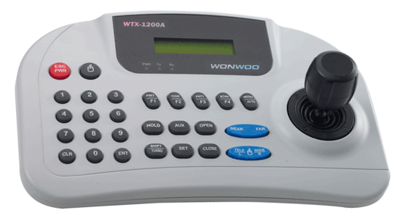
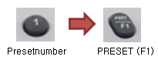
1. Place PAN/TILT/ZOOM to a desirable place
by Joystick.
2. Press Keypad No. 1.
3. Press F1 Key till “SET OK” appears in the bottom
right on the screen.
<Caution>
When setting PRESET by the shortcut key,
PRESET can be set in No.1-No.64 and, regarding
over No.65, it should be set up by OSD Menu.

※ WTX-1200A – Simple PRESET Shift ※
It works when OSD MENU is not activated.
Press F1 key shortly after pressing RRESET
number. And then, it moves to the
corresponding PRESET. However, it is valid only
up to PRESET no. 32 of which PRESET DEFINE
is set to ON.

※WTX-1200A - Simple TOUR operation※
It works when OSD MENU is not activated
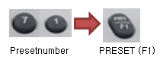
Press F1 key shortly after pressing Keypad No. 71.
It works when TOUR DEFINE is ON and TOUR
related MENU is set up properly.

※WTX-1200A - Simple PATTERN operation ※
It works when OSD MENU is not activated
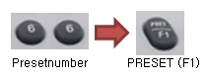
Press F1 key shortly after pressing Keypad No. 66.
It works when PATTERN DEFINE is ON and
PATTERN related MENU is set up properly.

※ WTX-1200A - Simple SCAN operation ※
It works when OSD MENU is not activated
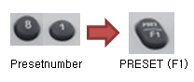
Press F1 key shortly after pressing Keypad No. 81.
It works when SCAN DEFINE is ON and SCAN
related MENU is set up properly.

※ WTX-1200A - Simple Sequency operation ※
It works when OSD MENU is not activated
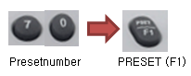
Press F1 key shortly after pressing Keypad No. 70.
It works when PRESET is set up.
※ Quick Operation Key Table ※

[PELCO D /P PROTOCOLS]

Number | Function
1~64+Preset | Setting Preset  Press Preset button over 2 seconds.
1~64+Preset | Executing Preset
66+Preset | Executing Scan
70+Preset | Executing Sequency
71+Preset | Executing Tour
81+Preset | Executing Pattern
95+Preset | IRIS OPEN (OSD Menu )
96+Preset | IRIS CLOSE

6. Produce Structure(mm)

- Specification
Model | 27x/ 33x/ 37x Speed Domes
Image sensor | 1/4” Super HAD CCD(27x)/ Color Vertical Double Density CCD(33x, 37x)
Effective Pixels | NTSC : 768(H) x 494(V), PAL : 752(H) x 582(V)
H. Resolutions | 550TVL(Color)/ 680TVL(B/W)
Synchronizing system | Internal
Scanning system | 2:1 Interlaced
Video output | VBS : 1.0Vp-p Composite, 75 ohms
S/N Ratio | More than 50dB(AGC off)
Min. illumination | 0.7Lux/F1.6(Color), 0.0002Lux(Sens-ups, x256), 0.06Lux/F1.6(B/W)
OSD | On/ Off
Digital zoom | On/ Off(x2, x4, x8, x10, x12)
Day & Night | Color/ BW/ AUTO(ICR)
Back Light Compensation | WDR(for 33x, 37x only)/ BLC/ HLC/ Off
Shutter Speed | Auto/ Manual (NTSC : 1/60~1/120,000 sec., PAL : 1/50 ~ 1/120,000 sec.)
White Balance | AWD/ Manual/ ATW(1,800°K ~ 10,500°K)
Gain Control | Low/ Middle/ High/ Off
Sens-up | On/ Off(2x ~ 256x)
3D Noise Filter | Low/ Middle/ High/ Off
Privacy | On/ Off(8 Programmable zones)
Preset | 256 Points
Digital Flip | On/ Off
Focus control | Auto/ Manual/ One Push
Iris control | Auto/ Manual
Motion Detection | On/ Off(Built-in Alarm output connector)
Protocol | RS-485(PELCO-D/P)
Alarm IN/OUT | 3/1
Power Source | 24VAC / 2A
Operating current | 35W Max.(Heater on)
Lens | Auto Focus Digital zoom
Aperture ratio | 37x : F1.6~F3.9, 33x : F1.6~F3.6, 27x : F1.6~F2.9
Pan/Tilt angle | Pan : 360°(400°/sec.), Tilt : 0°~180°(400°/sec.)
Operating temperature | -40°F~122°F(-40℃ ~ +50℃)
Humidity | Within 90% RH
Measurement(mm) | Outdoor : 255(Ø) x 377(H)
Weight(Approx.g) | 4,500(Outdoor)

